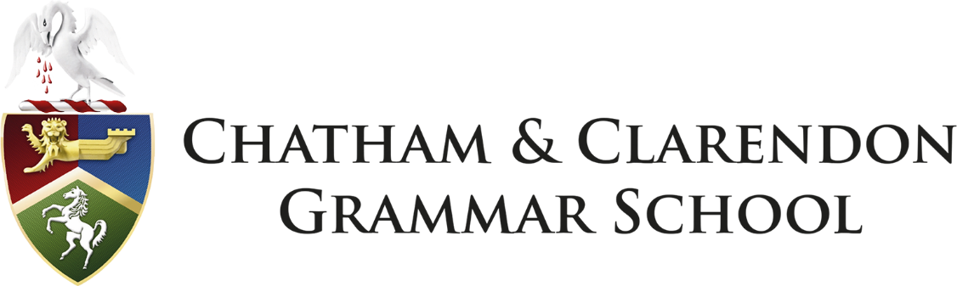

**Assistant Examinations Officer**

**(Part time – Term Time only plus 4 days)**

**CCGS Pay Scale Band 6 pt 17 – 20** £24,039 to £25,466   
(pro rata £6,735 to £7,135p.a.)

Chatham & Clarendon Grammar School is seeking to appoint an enthusiastic and computer literate assistant who will be able to assist the Examinations Manager in their role in overseeing the management of all examinations within the school. We are seeking an individual who can work on their own initiative, who is methodical, reliable and flexible.

The position has become vacant due to the previous post holder leaving to pursue a career in teaching. Required from 5 November 2024, the post is part time and term time only (plus four days in August) – the hours are 12 per week Tuesday to Thursday: 09.30am to 01.30pm and then full time in May and June.

Because of the nature of the role, it may require hours to be amended during the busy examination periods and reduced during the quieter periods of the academic year.

The school has a reputation for high standards of student behaviour, academic achievement and pastoral care and maintains an enviable programme of extra-curricular provision.

An electronic version of the application form and supporting material can be accessed from the ‘Vacancies’ section of the school website [www.ccgrammarschool.co.uk](http://www.ccgrammarschool.co.uk) Applications welcome via email to Teresa McMaster, Headteacher’s PA, at [tmcmaster@ccgrammarschool.co.uk](mailto:tmcmaster@ccgrammarschool.co.uk)

**Closing date: (8am) Tuesday 1st October 2024**

**Interview date: Tuesday 8th October 2024**

*Chatham & Clarendon Grammar School is committed to safeguarding and promoting the welfare of children and young people and expects all staff and volunteers to share this commitment. You are advised that this post is subject to the Rehabilitation of Offenders Act 1974 (Exceptions) Order 1975 (Amendment) (England and Wales) Order 2020 and therefore this post is subject to an Enhanced Disclosure Application to the Disclosure and Barring Service (DBS).  Please be aware that we are also required to undertake online recruitment checks (including social media) on shortlisted candidates under changes to Keeping Children Safe in Education.*